## Oak Woodland (OAK)

### General Information

### Cover Type Overview

* Crosswalk to EVeg: Regional Dominance Type 1
  + Gray Pine
  + Blue Oak
  + Valley Oak
* Crosswalk to EVeg: Regional Dominance Type 2
  + Any
* Crosswalk to BpS Model
  + 0611140: California Lower Montane Blue Oak-Foothill Pine Woodland and Savanna
* Crosswalk to Presettlement Fire Regime Type
  + Oak Woodland

Reviewed by:

* Becky Estes, Central Sierra Province Ecologist, USDA Forest Service

### Vegetation Description

The Oak Woodland landcover type is characterized by savannas, woodlands, or forests of either monospecific or mixed stands of various oak species. *Quercus douglasii*, *Quercus lobata, Quercus wislizenii,* and *Quercus garryana* are the major dominants. In oak forests where mixtures of tree oak and conifer species exist *Quercus kelloggii* and *Quercus chrysolepis* occur along with *Pinus sabiniana* (Allen-Diaz et al. 2007).

Both *Q. douglasii* and *Q. lobata* are endemic to California. *Q. lobata* are among the oldest and largest oaks in North America. Tree age can exceed 500 years. *Q. douglasii* are relatively slow-growing, long-lived trees. On *Q. douglasii-P. sabiniana* woodlands, *P. sabiniana* is taller and dominates the overstory, but is shorter-lived (at approximately 80 years) than *Q. douglasii* (150-250 years). *Q. douglasii* is usually the more abundant of the two trees, but *P. sabiniana* contributes as much basal area as *Q. douglasii* (Allen-Diaz et al. 2007).

Typical vegetation is dominated by open oak savannah with relatively uniform mature trees at low densities (<40% cover), where understory vegetation structure is a function of frequent surface fire that mediates woody plant development. In some instances and in some sites tree density will increase to 70% or more, forming a relatively stable hardwood forest type subject to surface fires in the hardwood litter and rare stand replacement fire (LandFire 2007).

In riparian forests, associates include *Platanus racemosa, Juglans hindsii, Acer negundo, Populus fremontii, Salix,* and *Fraxinus latifolia*. In drier areas and open woodlands, shrubs usually clump together in open areas with full sun. Species may include *Aesculus californica, Ceanothus, Arctostaphylos, Rhamnus, Toxicodendron diversilobum*, and *Cercis occidentalis* (Allen-Diaz et al. 2007). The shrub layer is best developed along natural drainages, becoming insignificant in the uplands. Ground cover consists of a well-developed carpet of grasses and forbs (Ritter 1988b). Common forbs include *Daucus*, *Geranium*, *Madia*, and *Trifolium*. Most understory cover is created by annual grasses, including *Bromus*, *Lolium*, and *Hordeum* (Allen-Diaz et al. 2007).

Oak recruitment is poor in many areas today, due to both natural and human causes. Many stands exist as groups of medium-to-large trees with few or no young oaks. There is concern that these woodlands may be slowly changing into savannas and grasslands as trees die and are not replaced. Mortality of oak saplings seems to be related to competition for moisture with grasses and forbs, wild and domestic animals feeding on acorns and seedlings, fire suppression, and flood control. Most recent work suggests that recruitment is limited not by reproduction, but by the establishment and survival of saplings (Allen-Diaz et al. 2007).

### Distribution

Oak Woodland has a patchy distribution embedded in a matrix of agriculture, urban development, grasslands, riparian forests, and other conifer and oak woodland types. It occurs in a band along the western Sierra Nevada foothills, generally below 800 m (2642 feet) in elevation, although individual species described here are capable of surviving at higher elevations. In general, tree density is highest along natural drainages with deeper soils, and lower in uplands and on steeper slopes. The transition from savanna to woodland to forest is largely driven by soil, precipitation, and elevation (Allen-Diaz et al. 2007).

Soils in this type vary significantly, with different types conducive to the establishment of differing dominant tree species. *Q. lobata* is best developed on deep, well-drained alluvial soils, usually in valley bottoms (Ritter 1988b). *Q. wislizeni* becomes more abundant on steeper slopes, shallower soils, and at higher elevations. *Q. douglasii* woodlands occur on a wide range of soils; however, they are often shallow, rocky, infertile, and well drained. The overstory ranges from sparsely scattered trees on poor sites to nearly closed canopies on good quality sites (Allen-Diaz et al. 2007, Ritter 1988a). *Q. douglasii-P. sabiniana* woodlands are found on variety of generally well-drained parent materials, ranging from gravelly loam through stony clay loam. They occupy steeper, drier slopes with shallower and rockier soils than pure oak woodlands (Verner 1988).

**Disturbances**

### Wildfire

An overstory dominated by deciduous hardwood species results in an herbaceous surface fuel complex dominating fuel/fire influences (LandFire 2007). Because of the long period of human habitation of oak woodlands, it is extremely difficult to define the “natural” fire regime. Lightning-caused fires certainly occurred in the past, but decades may pass between these events. Native Americans used fire in their stewardship of oak woodlands; however, it is difficult to document the frequency, intensity, and extent of burning by Native Americans. Some estimate the fire return interval (FRI) of that period to be around 25 years. The first European settlers continued to use fire as a management practice; burning intervals ranged from 8-15 years. Ranchers continued the practice through the 1950s, but since then fire suppression has emerged as the standard management policy (Allen-Diaz et al. 2007).

The fire regime which produced this landcover type is thought to be frequent; mortality depends on vegetation vulnerability and wildfire intensity. Younger oaks are fire-sensitive and frequently killed by even low severity fires. However, they typically sprout post-disturbance. Older, decadant oaks are not likely to sprout after being damaged or killed by fire. Therefore, younger stands are more likely to regrow after fires and fire exclusion can have a significant effect on stand structure. *P. sabiniana*’s regeneration is dependent on regeneration from seed, although it, too, is fire-adapted. It also grows faster than *Q. douglasii* and is an important colonizer (Allen-Diaz et al. 2007).

Data on FRIs are available from a few review papers. Skinner and Chang (1996) aggregated FRIs from the Sierra Nevada and separated pre-1850 data from overall data. For blue-oak gray pine woodlands in the Sierra Nevada, one study found presettlement FRIs ranged from 8 to 49 years, with a median of 29. Another found mean presettlement FRIs ranging from 10-14 years. Van de Water and Safford’s 2011 review paper aggregates hundreds of articles, conference proceedings, and LandFire data on fire return intervals, with an emphasis on Californian sources. For the Oak Woodland type, they report a mean and median return interval of 12 years, mean min of 5 years, and mean max of 45 years. LandFire’s California Lower Montane Blue Oak-Foothill Pine Woodland and Savanna for the northern Sierra estimated fire intervals of 120 years for replacement fire, 500 years for mixed fire, and 10 years for surface fire, with an overall interval of 9 years (2007). We recalculated these numbers using condition-specific information and using only high and low mortality fire categories, which resulted in a mean FRI of 122 years for high mortality fire, 10 years for low mortality fire, and 9 years for any fire.

Table 1. Fire return intervals (years) and percentage of high versus low mortality fires. Numbers for OAK on were derived from BpS model 0611140 (LandFire 2007), Van de Water and Safford (2011), Skinner and Chang (1996), and Estes (pers. comm. 2013).

|  |  |  |  |  |  |  |
| --- | --- | --- | --- | --- | --- | --- |
| **Variant** | **Modifier** | **Fire Mortality** | **Mean** | **Min** | **Max** | **% of Fires** |
| OAK | None | High | 122 | – | – | 15 |
| Low | 10 | – | – | 85 |
| All Fires | 12 | 5 | 49 | 100 |

### Other Disturbance

Other disturbances are not currently modeled, but may, depending on the condition affected and mortality levels, reset patches to early development, maintain existing condition classes, or shift/accelerate succession to a more open condition.

### Vegetation Condition Classes

We recognize four separate condition classes for OAK: Early Development (ED), Mid Development Open (MD), Late Development Open (LDO), and Late Development Closed (LDC). We use condition classes not in the sense of fire regime condition classes, but as an alternative to “successional” classes that imply a linear progression of states and tend not to incorporate disturbance. The condition classes identified here are derived from a combination of successional processes and anthropogenic and natural disturbance, and are intended to represent a composition and structural condition that can be arrived at from multiple other conditions described for that landcover type. Thus our condition classes incorporate age, size, canopy cover, and vegetation composition as well as relative seral stages. In general, the delineation of stages has originated from the LandFire biophysical setting model descriptive of a given landcover type; however, condition classes are not necessarily identical to the classes identified in those models.

### Early Development (ED)

**Description** Post-replacement sapling/regeneration phase. Largely a function of either early seral remaining in early seral due to replacement fire, or due to less common late seral replacement fire. Re-establishment can occur from basal resprouting or sexual reproduction, depending on composition, growth form, and seed dynamics. Patch size likely ranges from very small gap recruitment to areas approximately 100 acres. May include *Q. douglasii, Q. chrysolepis, Q. garryana, P. sabiniana*, and a variety of shrubs (LandFire 2007).

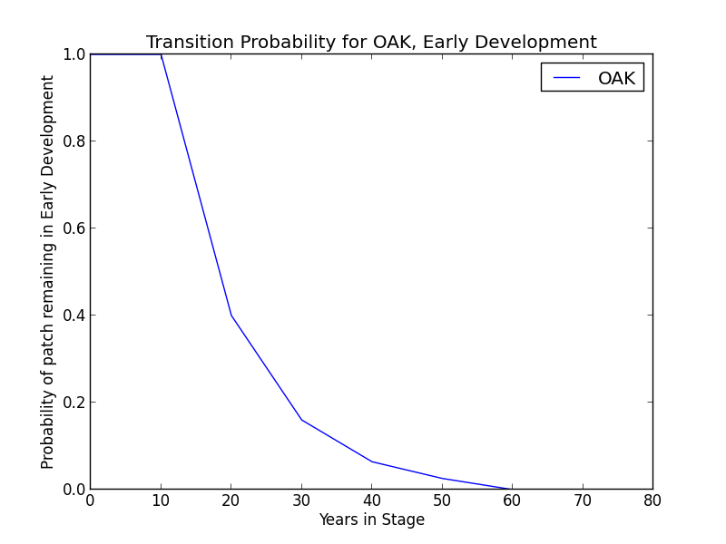

**Succession Transition** In the absence of disturbance, patches in this condition will begin transitioning to MD at 20 years at a rate of 0.6 per time step. At 60 years in ED, all remaining patches transition to MD.

**Wildfire Transition** High mortality wildfire (100% of fires in this condition) recycles the patch through the ED condition. Low mortality wildfire is not modeled for this condition.

### Mid Development (MD)

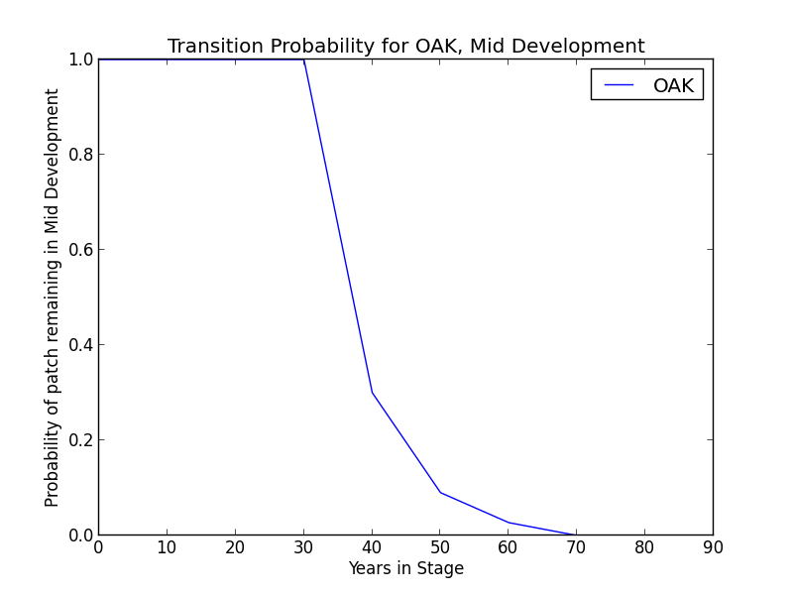**Description** Intermediate phase; older than 20 years – some new recruitment of cohorts occurs in the later stages of this condition, increasing tree density. Periodic surface fire is relatively common, but replacement fire rare due to low intensity fire type and resilience of typical species to top kill. Patch size is typically in the hundreds of acres. May include *Q. douglasii, Q. chrysolepis, Q. garryana, P. sabiniana*, and a variety of shrubs (LandFire 2007).

**Succession Transition** In the absence of stand-replacing disturbance, patches in this condition will begin transitioning to LDO at 40 years at a rate of 0.7 per time step. At 70 years in MD, all remaining patches transition to MD.

**Wildfire Transition** High mortality wildfire (4.8% of fires in this condition) recycles the patch through the ED condition. Low mortality fire (95.2%) maintains the MDO condition and allows for succession to LDO.

### Late Development – Open (LDO)

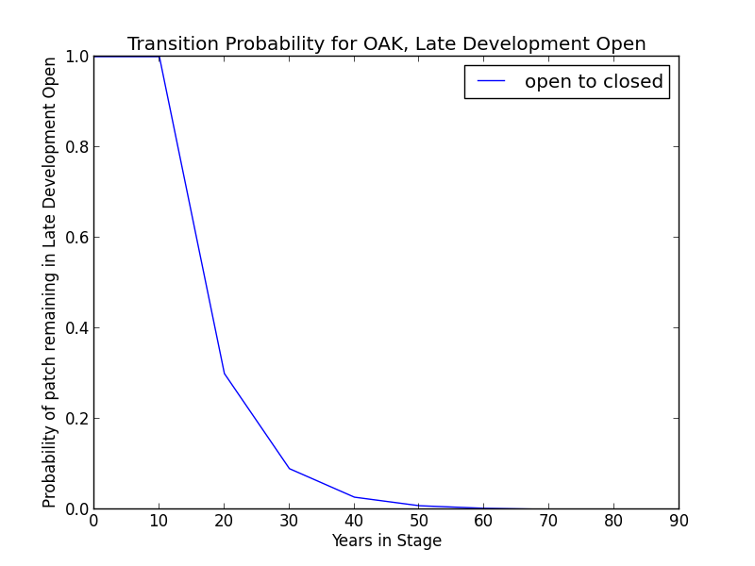**Description** Open woodland with mature oak and conifer trees. This condition is highly stable, as most fire is frequent, low severity fire acting as a maintenance agent. Tree density and canopy cover increase over time to relatively stable conditions. In some cases woody encroachment and increased tree density occurs under missed fire cycles. If *P. sabiniana* occurs, it quickly becomes very large. Some replacement fire occurs initiating secondary succession in the ED condition. Patch size in the hundreds, to possibly thousands, of acres. Canopy cover ranges from 11-50%. May include *Q. douglasii, Q. chrysolepis, Q. garryana, P. sabiniana*, and a variety of shrubs (LandFire 2007).

**Succession Transition** In the absence of disturbance, patches in this condition will begin transitioning to LDC after 20 years at a rate of 0.7 per time step. After 60 years in LDO without any disturbance, all eligible patches transition to LDC.

**Wildfire Transition** High mortality wildfire (7.4% of fires in this condition) recycles the patch through the ED condition. Low mortality fire (92.6%) maintains the LDO condition.

### Late Development – Closed (LDC)

**Description** Late seral stage arising from a rare period of no fire in the LDO condition for at least 20 years, allowing woody understory encroachment and higher tree density. If *P. sabiniana* occurs, it quickly becomes very large. Fire that does not effect a change in condition is rare; low mortality fire is the normal pathway back to late-seral open conditions, while high mortality results in a return to early seral conditions. Patch size is likely in the tens of acres. May include *Q. douglasii, Q. chrysolepis, Q. garryana, P. sabiniana*, and a variety of shrubs. If the closed condition persists for decades and *P. sabiniana* is present, it can begin to shade out the oak trees (LandFire 2007).

**Succession Transition** In the absence of disturbance, patches in this condition will maintain.

**Wildfire Transition** High mortality wildfire (50% of fires in this condition) recycles the patch through the ED condition. Low mortality fire (50%) opens the patch up to LDO.

**Condition Classification**

Table 2. Classification of cover condition for OAK. Diameter at Breast Height (DBH) and Cover From Above (CFA) values taken from EVeg polygons. DBH categories are: null, 0-0.9”, 1-4.9”, 5-9.9”, 10-19.9”, 20-29.9”, 30”+. CFA categories are null, 0-10%, 10-20%, … , 90-100%. Each row in the table below should be read with a boolean AND across each column.

|  |  |  |  |  |  |
| --- | --- | --- | --- | --- | --- |
| Cover Condition | Overstory Tree  Diameter 1 (DBH) | Overstory Tree  Diameter 2 (DBH) | Total Tree  CFA (%) | Conifer  CFA (%) | Hardwood  CFA (%) |
| Early | 0-4.9” | any | any | any | any |
| Mid | 5-9.9” | any | any | any | any |
| Late Open | 10”+ | any | <50 | any | any |
| Late Open | 10”+ | any | null | <50 | <50 |
| Late Closed | 10”+ | any | >50 | any | any |
| Late Closed | 10”+ | any | null | >50 | any |
| Late Closed | 10”+ | any | null | any | >50 |

**Draft Model**

(See PDF) Disturbance-Succession model for OAK.

**References**

Allen-Diaz, Barbara, Richard Standiford, and Randall D. Jackson. “Oak Woodlands and Forests.” In *Terrestrial Vegetation of California, 3rd Edition*, edited by Michael Barbour, Todd Keeler-Wolf, and Allan A. Schoenherr, 313-338. Berkeley and Los Angeles: University of California Press, 2007.

“CalVeg Zone 1.” Vegetation Descriptions. *Vegetation Classification and Mapping*. 11 December 2008. U.S. Forest Service. <http://www.fs.usda.gov/Internet/FSE_DOCUMENTS/fsbdev3_046448.pdf>. Accessed 2 April 2013.

LandFire. “Biophysical Setting Models.” Biophysical Setting 0611140: California Lower Montane Blue Oak-Foothill Pine Woodland and Savanna. 2007. LANDFIRE Project, U.S. Department of Agriculture, Forest Service; U.S. Department of the Interior. <http://www.landfire.gov/national_veg_models_op2.php>. Accessed 9 November 2012.

Ritter, Lyman V. “Blue Oak Woodland (BOW).” ).” *A Guide to Wildlife Habitats of California*, edited by Kenneth E. Mayer and William F. Laudenslayer. California Deparment of Fish and Game, 1988a. <http://www.dfg.ca.gov/biogeodata/cwhr/pdfs/BOW.pdf>. Accessed 4 December 2012.

Ritter, Lyman V. “Valley Oak Woodland (VOW).” ).” *A Guide to Wildlife Habitats of California*, edited by Kenneth E. Mayer and William F. Laudenslayer. California Deparment of Fish and Game, 1988b. <http://www.dfg.ca.gov/biogeodata/cwhr/pdfs/VOW.pdf>. Accessed 4 December 2012.

Skinner, Carl N. and Chi-Ru Chang. “Fire Regimes, Past and Present.” *Sierra Nevada Ecosystem Project: Final report to Congress, vol. II, Assessments and scientific basis for management options*. Davis: University of California, Centers for Water and Wildland Resources, 1996.

Van de Water, Kip M. and Hugh D. Safford. “A Summary of Fire Frequency Estimates for California Vegetation Before Euro-American Settlement.” *Fire Ecology* 7.3 (2011): 26-57. doi: 10.4996/fireecology.0703026.

Verner, Jared. “Blue Oak-Foothill Pine (BOP).” ).” *A Guide to Wildlife Habitats of California*, edited by Kenneth E. Mayer and William F. Laudenslayer. California Deparment of Fish and Game, 1988. <http://www.dfg.ca.gov/biogeodata/cwhr/pdfs/BOP.pdf>. Accessed 4 December 2012.